Zbtool User Guide

|  |  |  |  |
| --- | --- | --- | --- |
| Version | Changed Item | Author | Date |
| 1.0 | First version | Feng.He | 2020.06.15 |
| 1.1 | Add group、scene | Feng.He | 2020.06.18 |

## 1.1 Description

Zbtool is a cmd line tool for debug gl-zigbee module which bases on gl-zb-api. You can use it for quick controning and managing zigbee network and devices.

## 1.2 Command Table

|  |  |  |
| --- | --- | --- |
| Command | Need Parameters | Simple Description |
| help | NO | Get command list |
| get_module_message | NO | Get zigbee module message |
| get_nwk_status | NO | Get current network status |
| get_dev_list | NO | Get current child/neighbor device table |
| create_nwk | YES | Create a new zigbee network(as coordinator) |
| leave_nwk | NO | Destroy current zigbee network |
| allow_join | YES | Allow device join in current zigbee network |
| delete_dev | YES | Remove device from zigbee network |
| listen | NO | Listen the module_message callback |
| global-zcl | YES | Create and send a global zcl cmd |
| zcl-on/off | YES | Create and send a on-off cluster cmd |
| zcl-window_covering | YES | Create and send a window_covering cluster cmd |
| zcl-level_control | YES | Create and send a level_control cluster cmd |
| zcl-color_control | YES | Create and send a color_control cluster cmd |
| zcl-group | YES | Create and send a group cluster cmd |
| zcl-scene | YES | Create and send a scene cluster cmd |

## 1.3 Command Instruction

### 1.3.1 help

Get command list

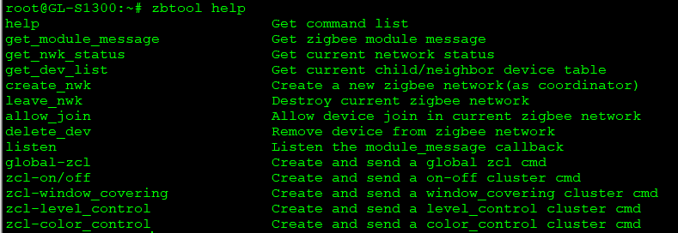

### 1.3.2 get_module_message

Get zigbee module message



### 1.3.3 get_nwk_status

Get current network status

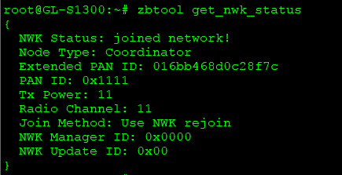

### 1.3.4 get_dev_list

Get current child/neighbor device table.

A child device is usually a zigbee-end_device or zigbee-sleepy_end_device mounted on the current device. A neighbor device is usually a zigbee-router_device.

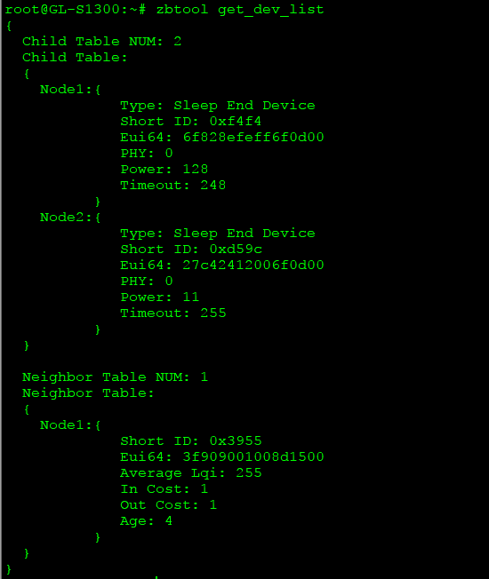

### 1.3.5 create_nwk

Create a new zigbee network(as coordinator).

Parameters: pan ID、 channel、 TX power



### 1.3.6 leave_nwk

Destroy current zigbee network



### 1.3.7 allow_join

Allow device join in current zigbee network

Parameters: limit_time(0-255)



### 1.3.8 delete_dev

Remove device from zigbee network

Parameters: target device short ID、target device EUI64



### 1.3.9 Listen

Listen the module_message callback.

There are two types of module message, zcl report message and zigbee device manage message.

**zcl report message:**

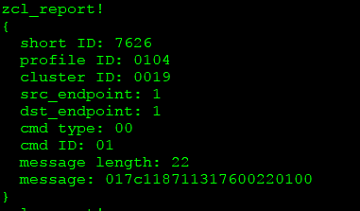

**zigbee device manage message:**

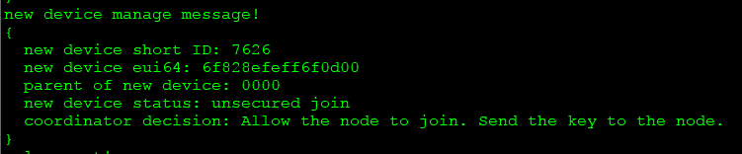

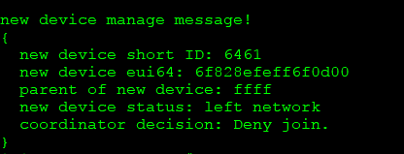

### 1.3.10 global-zcl

Create and send a global zcl cmd.

Parameters: target device short ID、cluster ID、CMD ID、frame type、data

frame type：0: unicast; 1: multicast; 2: broadcast

Note: API support all global zcl cmd, but zbtool only implemented “read attribute(0x00)” cmd now.



Get cmd resp (listen):

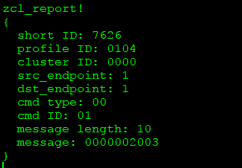

### 1.3.11 zcl-on/off

Create and send a on-off cluster cmd

Parameters: target device short ID、CMD ID、frame type

CMD ID：0-off；1-on；2-toggle

frame type: 0: unicast; 1: multicast; 2: broadcast

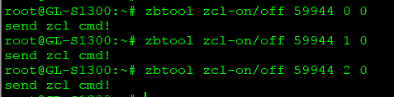

### 1.3.12 zcl-window_covering

Create and send a window_covering cluster cmd

Parameters: target device short ID、CMD ID、frame type

CMD ID：0-down；1-up；2-stop

frame type: 0: unicast; 1: multicast; 2: broadcast

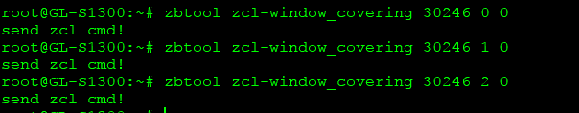

### 1.3.13 zcl-level_control

Create and send a level_control cluster cmd

Note: API support all zcl cmd, but zbtool only implemented “move to level(0x00)” cmd now.

Parameters: target device short ID、CMD ID、level(0-255)、frame type

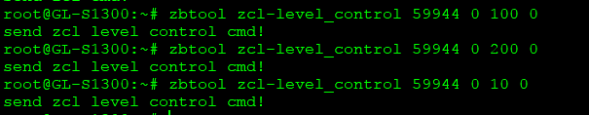

### 1.3.14 zcl-color_control

Create and send a color_control cluster cmd

Note: API support all zcl cmd, but zbtool only implemented “Move to Color(0x07)” and “Move to Color Temperature(0x0a)” cmd now.

Parameters(Move to Color): target device short ID、CMD ID、x value、y value、frame type

Parameters(Move to Color Temperature): target device short ID、CMD ID、color_temperature、frame type

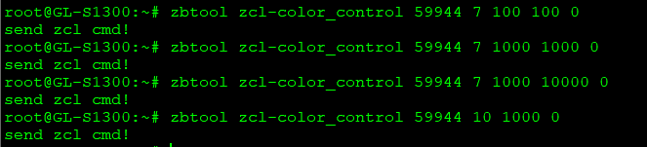

### 1.3.15 zcl-group

Create and send a group cluster cmd

Parameters: target device short ID、CMD ID、cmd data、frame type

Cmd data: data of zcl message(little endian)

“add group” cmd

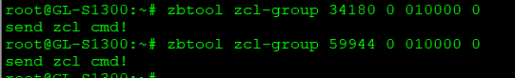

### 1.3.15 zcl-scene

Create and send a scene cluster cmd

Parameters: target device short ID、CMD ID、cmd data、frame type

Cmd data: data of zcl message(little endian)

“add scene” cmd

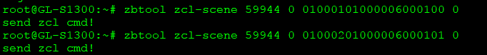

“recall scene” cmd

